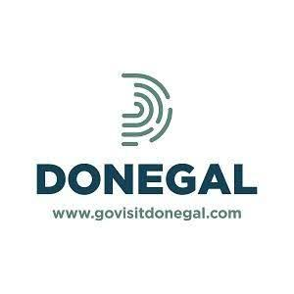**DONEGAL TOURISM ASSOCIATE MEMBERSHIP APPLICATION 2025**

TO APPLY, PLEASE COMPLETE AND RETURN THE FORM BELOW

|  |  |
| --- | --- |
| Business Name |  |
| Contact Name |  |
| Position |  |
| Address |  |
|  |  |
| Telephone Number |  |
| Email |  |
| Website |  |
| Category  *for example*   * *Accommodation Provider* * *Restaurant* * *Activity Provider* * *Adventure Tourism* |  |
| Signature |  |
| Date |  |

Annual Membership Fee **€20**

You can pay by bank transfer:

**Bank Name:** AIB, 61 Upper Main Street, Letterkenny

**Account Name:** County Donegal Tourism Limited

**Account Number:** 08717-022 Sort Code: 93-73-47

**IBAN:** IE65 AIBK 9373 4708 7170 22 (**BIC:** AIBKIE2D)

Alternatively, you can pay by cheque; please make cheques payable to: **Donegal Tourism Ltd**

and post, together with the application form, to **Donegal Tourism Ltd, Donegal Public Service Centre, Drumlonagher, Donegal Town, Co Donegal**

□ GDPR: I give Donegal Tourism my consent to keep my details on file and add my e-mail address to the MailChimp database of contacts.

You can pay by bank transfer:

**Bank Name:** AIB, 61 Upper Main Street, Letterkenny

**Account Name:** County Donegal Tourism Limited

**Account Number:** 08717-022 Sort Code: 93-73-47

**IBAN:** IE65 AIBK 9373 4708 7170 22 (**BIC:** AIBKIE2D)

You can pay by bank transfer:

**Bank Name:** AIB, 61 Upper Main Street, Letterkenny

**Account Name:** County Donegal Tourism Limited

**Account Number:** 08717-022 Sort Code: 93-73-47

**IBAN:** IE65 AIBK 9373 4708 7170 22 (**BIC:** AIBKIE2D)